Name: Sasanka Sekhar Kundu
Roll No: 150096725118
Date of Submission: 11th November 2025

Assignment 3
Git & github

Git and GitHub Assignment:
PART A - Short Answer Questions
- What is Git?
Answer: Git is a tool that helps track changes in files and projects. It is mainly used for programming and version control.
- Why do we use Git?
Answer: We use Git to save different versions of our work, collaborate with others, and easily go back to older versions if needed.
- What is a Version Control System (VCS)?
Answer: A VCS is software that helps manage changes to code or documents over time. It keeps a record of every update.
Example : GitHub and more….
- What command is used to check the Git version?
Answer:

- What is a repository in Git?
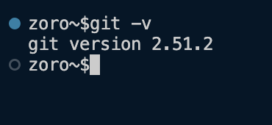
Answer: A repository (repo) is a folder where Git tracks all your project files and their history.
- What command is used to create a new Git repository?
Answer:
- What is the .git folder used for?
Answer: The .git folder stores all the information about your repository — like commits, branches, and settings.
- What command is used to check Git configuration details?
Answer:
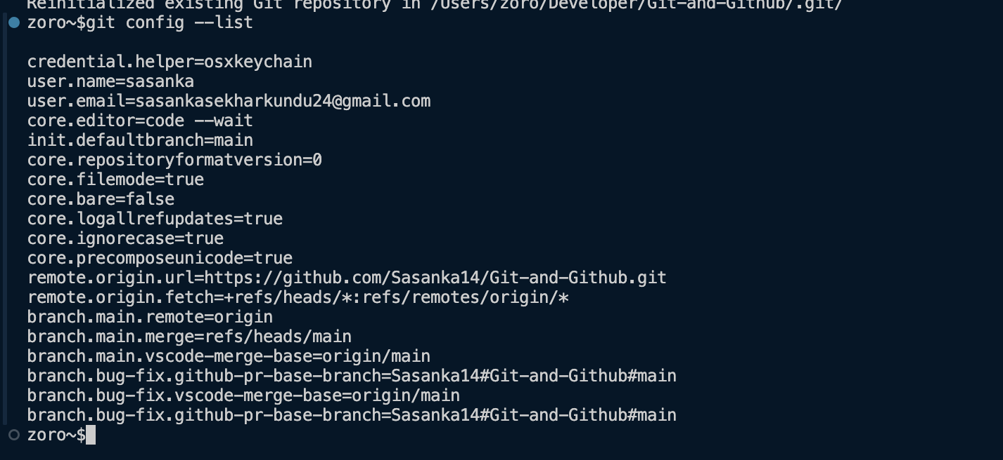
- Write the command to set your username in Git.
Answer:
- Write the command to set your email ID in Git.
Answer:

PART B - Fill in the Blanks
1. Git is a version control system.
2. The command 'git init' is used to create/initialize a repository.
3. To check the installed version of Git, we use git --version.
4. The command 'git config --global user.name' is used to set your username.
5. The folder '.git' is hidden by default.

PART C - Hands-on Practice
Perform these steps in Terminal (Mac) or Command Prompt (Windows)
- Create a new folder named myproject

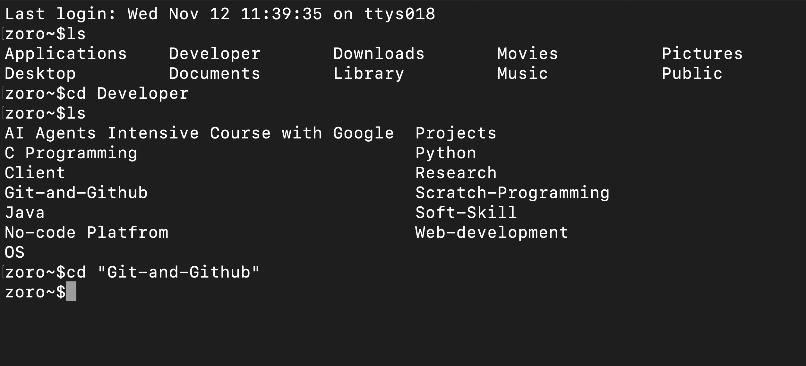
- Initialize Git in this folder

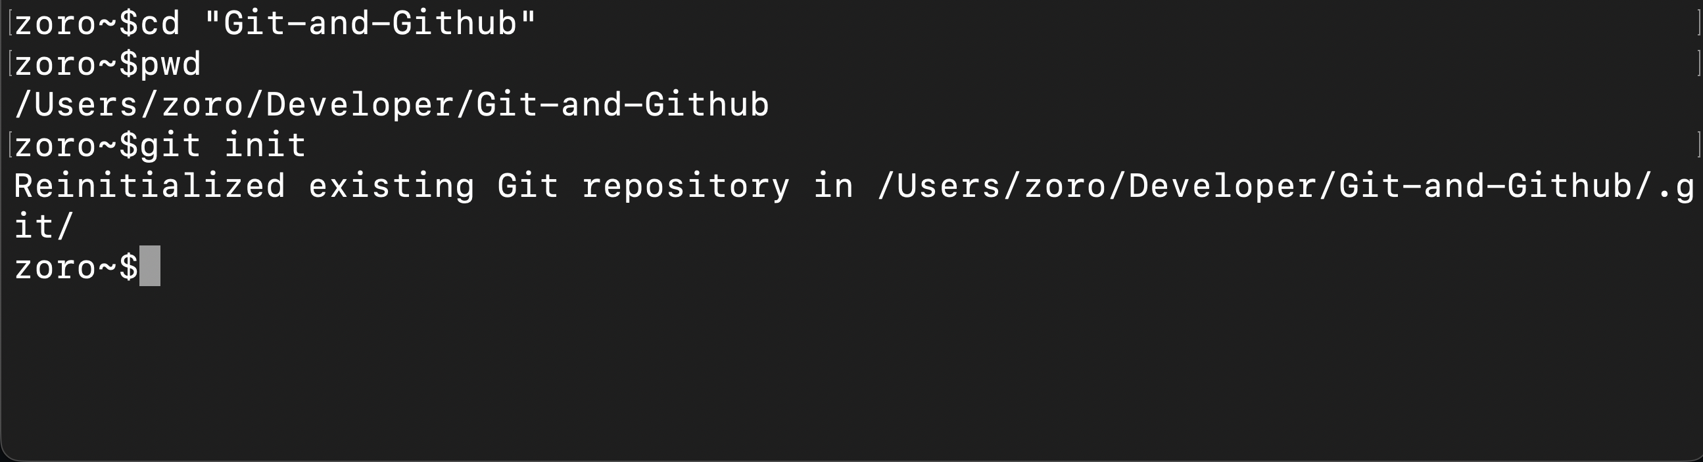
- Configure your Git username and email

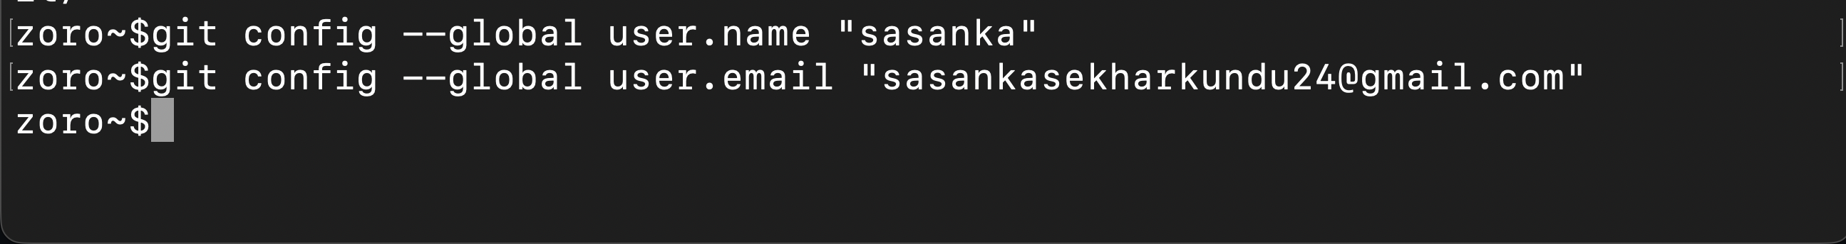
- Check your Git configuration

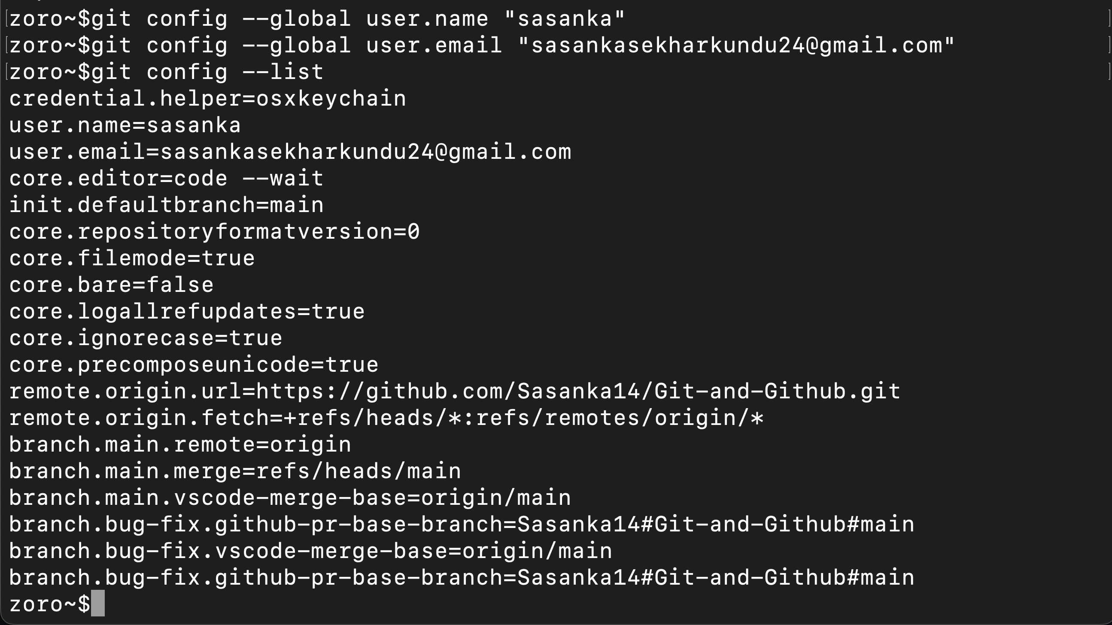
- List all files (including hidden ones)

